

**HTML**

HTML is the standard markup language for Web pages with it you can create your own Website. It consists of a series of elements tell the browser how to display the content.

Html 5 version not supported by default in old browsers.

Html element consists of 3 parts:

1. Start tag 2- Some content 3- End tag

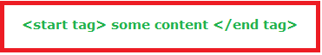

**Empty elements:** are HTML elements having no content and no end tag it has a self-close.

**Ex:** <br/>, <img/>, <hr/> elements.

**Html Dom Tree**

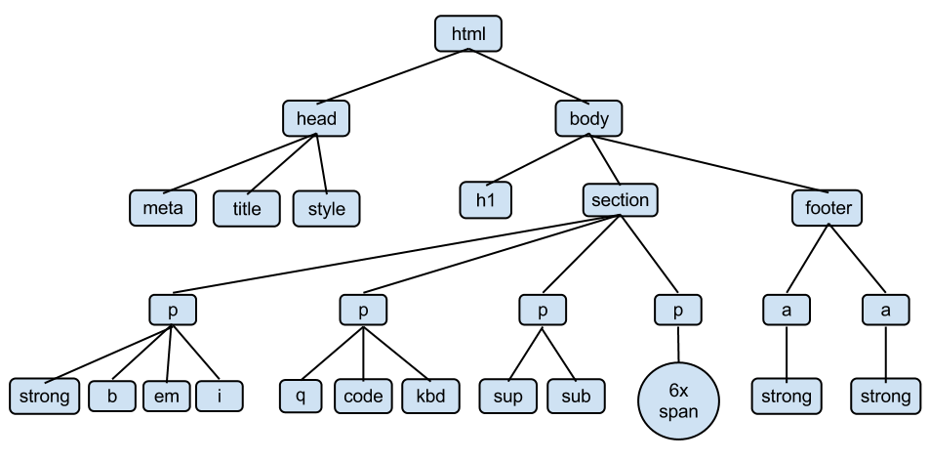

* Dom tree is drawn based on the **relationship** between the parents and their Childs that present in html elements.
* Dom tree is a finite set of nodes, these nodes are presented by oval shapes; and are connected with each other by straight lines called edges.
* Top or first node in this tree is called root node.
* The node that containing one child or more is called parent node while the node with no Childs is called leaf node.
* Nodes that visited in the path from the selected node to the root node are called ancestors.

**Note:** Ancestor include: Parents, Grandparents, and Grand grandparents….etc.

* Two or more nodes that have the same parent are called siblings

**Note:** Siblings means brother.

* Siblings (Brothers) that located sides by side are called Adjacent Siblings like; q, code, Kbd. Also q, code But ~~kbd, q aren’t adjacent sibling~~
* Descendants of a node are any node falling under the selected node tree (i.e. Direct Children, Children’s children, or any node that can be reachable from the selected node down to the leaf node).

Global attributes

Global attributes are attributes that can be embedded in all html elements. These attributes are:

a) Accesskey b) Contenteditable c) tabindex d) Data e) Class f) Id g) Dir h) Hidden i) Lang j) Spellcheck k) draggable l) Translate m) Title n) style

**1- Accesskey:**

The accesskey attribute specifies a shortcut key to activate/focus an element.

The access attribute value must be a single character (a letter or a digit).

Note: The way of accessing the shortcut key element is varying in different browsers:

|  |  |  |  |
| --- | --- | --- | --- |
| **Browser** | **Windows** | **Linux** | **Mac** |
| Chrome | [Alt] + *accesskey* | [Alt] + *accesskey* | [Control] + [Alt] + *accesskey* |
| Edge | [Alt] + *accesskey* | N/A | N/A |
| Internet Explorer | [Alt] + *accesskey* | N/A | N/A |
| Firefox | [Alt] + [Shift] + *accesskey* | [Alt] + [Shift] + *accesskey* | [Control] + [Alt] + *accesskey* |
| Safari | [Alt] + *accesskey* | N/A | [Control] + [Alt] + *accesskey* |
| Opera | Opera 15 or newer: [Alt] + *accesskey* Opera 12.1 or older: [Shift] + [Esc] + *accesskey* |

Ex:

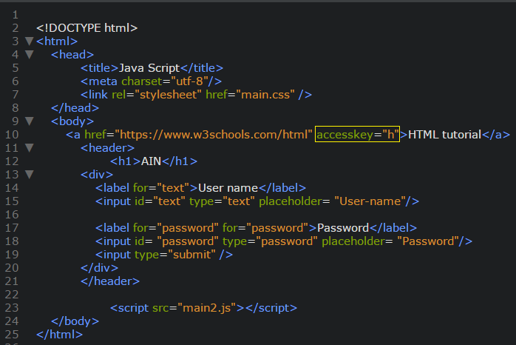

**2- conteneditable:**

The contenteditable attribute specifies whether the content of an element is editable (true) or not (false).

Note: When the contenteditable attribute is not set on an element, the element will inherit it from its parent.

Ex:

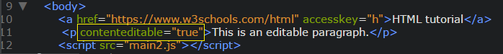

**3) tabindex:**

The tabindex attribute specifies the tab order of an element (when the "tab" button is used for navigating). The tabindex attribute can be used on any HTML element (it will validate on any HTML element. However, it is not necessarily useful).

Ex:

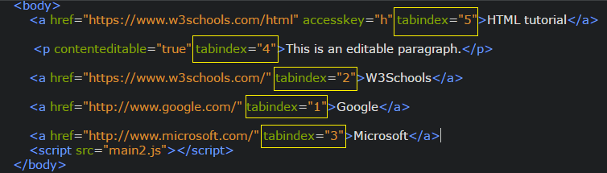

**4)data-\***

**5) dir**

The dir attribute specifies the **text direction** of the element's content.

Has three values:

|  |  |
| --- | --- |
| ltr | Default. Left-to-right text direction |
| rtl | Right-to-left text direction |
| auto | Let the browser figure out the text direction, based on the content (only recommended if the text direction is unknown) |



**6) hidden:**

The hidden attribute is a boolean attribute. The hidden attribute can also be used to keep a user from seeing an element until some other condition has been met (like selecting a checkbox, etc.). Then, a JavaScript could remove the hidden attribute, and make the element visible.



**7) id:**

The id attribute specifies a unique id for an HTML element (the value must be unique within the HTML document).

The id attribute is most used to point to a style in a style sheet, and by JavaScript (via the HTML DOM) to manipulate the element with the specific id.

Id naming rules that id: 1- Must contain at least one character. 2- Must not contain any space characters



**8) class:**

The class attribute specifies one or more classnames for an element.

The class attribute is mostly used to point to a class in a style sheet. However, it can also be used by a JavaScript (via the HTML DOM) to make changes to HTML elements with a specified class.

Class naming rules that class: 1- Must begin with a letter A-Z or a-z 2-Can be followed by: letters (A-Za-z), digits (0-9), hyphens ("-"), and underscores ("_").



**9) lang:**

The lang attribute specifies the language of the element's content.

Common examples are "en" for English, "es" for Spanish, "fr" for French, and so on.



**10) style**

The style attribute specifies an inline style for an element.

The style attribute will override any style set globally, e.g. styles specified in the <style> tag or in an external style sheet.

The style attribute can be used on any HTML element (it will validate on any HTML element. However, it is not necessarily useful).



**11) spellcheck**

The spellcheck attribute specifies whether the element is to have its spelling and grammar checked (true) or not (false).

The following can be spellchecked:

Text values in input elements (not password)

Text in <textarea> elements

Text in editable elements



**12) title:**

The title attribute specifies extra information about an element.

The information is most often shown as a tooltip text when the mouse moves over the element.

The title attribute can be used on any HTML element (it will validate on any HTML element. However, it is not necessarily useful).



**13) translate:**

The translate attribute specifies whether the content of an element should be translated or not. Not supported in any browser.

**14) draggable:**

The draggable attribute specifies whether an element is draggable (true) or not (false) or uses the default behavior of your browser (auto).

Tip: Links and images are draggable by default.

Tip: The draggable attribute is often used in drag and drop operations. Read our [HTML Drag and Drop tutorial](https://www.w3schools.com/html/html5_draganddrop.asp) to learn more.

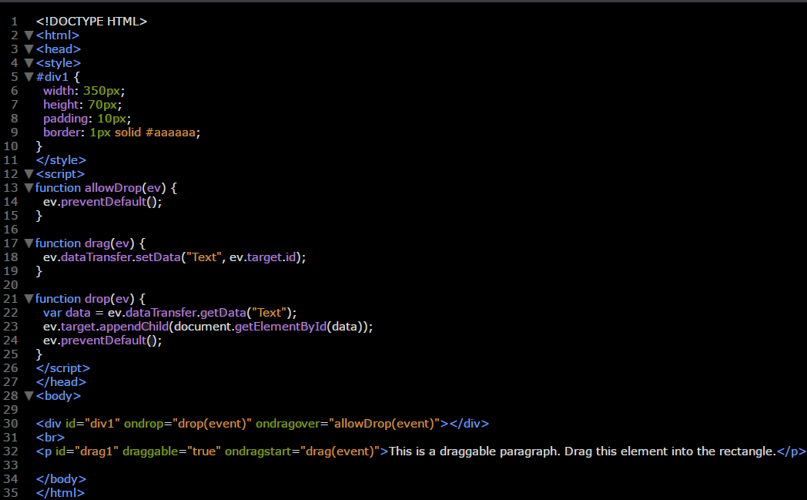

**Tips in Html**

1. The correct order of <head> tags is:

<head>

<meta charset="utf-8"/>

<meta name="description"/>

<meta name="keyword"/>

<title> </title>

<style></style>

<script></script>

1. Always write <DOCTYPE html> in the begging of your page.
2. Determine a name for each <input> because if the data in the input without name won’t be sent to backend page when pressing submit button.
3. The “HTML5 Shiv” file enables you to use HTML5 elements in old browsers like Internet Explorer. Download file from here <https://github.com/aFarkas/html5shiv>
4. Use lowercase letters to make your code more beautiful and readable.
5. Closing all tags even if it self-content tags.
6. Its betters to use quotes even you can ignore it, but if your value of a specific tag consists of more than one word the error will occurs.
7. Use <meta> tags it’s important in SEO engines.
8. Use viewport meta tag to make your site more responsie.
9. Use vw unit to specify text size. This unit makes your text responsive also. [1vw=100cm=1% of viewport width]
10. Use comments to organize your code.
11. Use lower case letters to naming your project’s files as there is some websites like “Unix and Apache” is a case sensitive for files letters.